Project Title: Probability Art

url: <https://git.cs.vt.edu/kaleb18/probability-art-blackjack>

Team: 7

Team members: Kaleb Barker, Tyler Mills, Yi Lu, Trey Orr

Blackjack is the most popular casino game in the world. Not only because it is simple to play, but because there is so much chance involved. With our project, you will be able to visualize the chances and probabilities that go into winning and losing a game of blackjack.

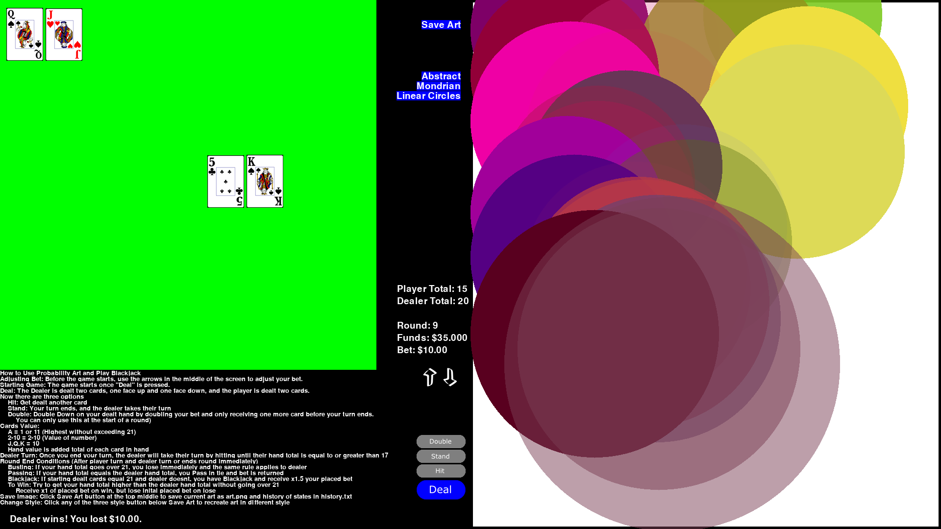

We use three different unique styles to go about visualizing the different probabilities and factors at work for each round or action in a game. These different styles can be switched dynamically to show how the game would have looked under a different style. The Abstract style visualizes the game using triangles that are colored and placed based on these different probabilities and factors for a state, such as win chance for a hand controlling the green value of the color and bust chance deciding where the triangle will be placed.

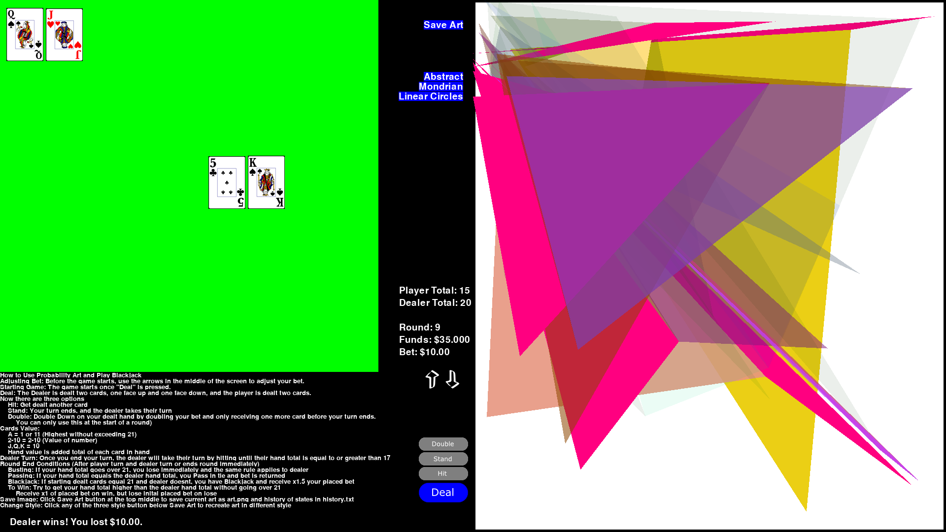

The Linear Circle style creates a linear chain of circles that overlap and progress downward as different actions take place. Different elements, such as opacity and color, are controlled by different factors like bust chance and states of the hands of the dealer and player.



The Piet Mondrian inspired style visualizes the game using rectangles with colors representing the actions made and sizes corresponding to the win probabilities.

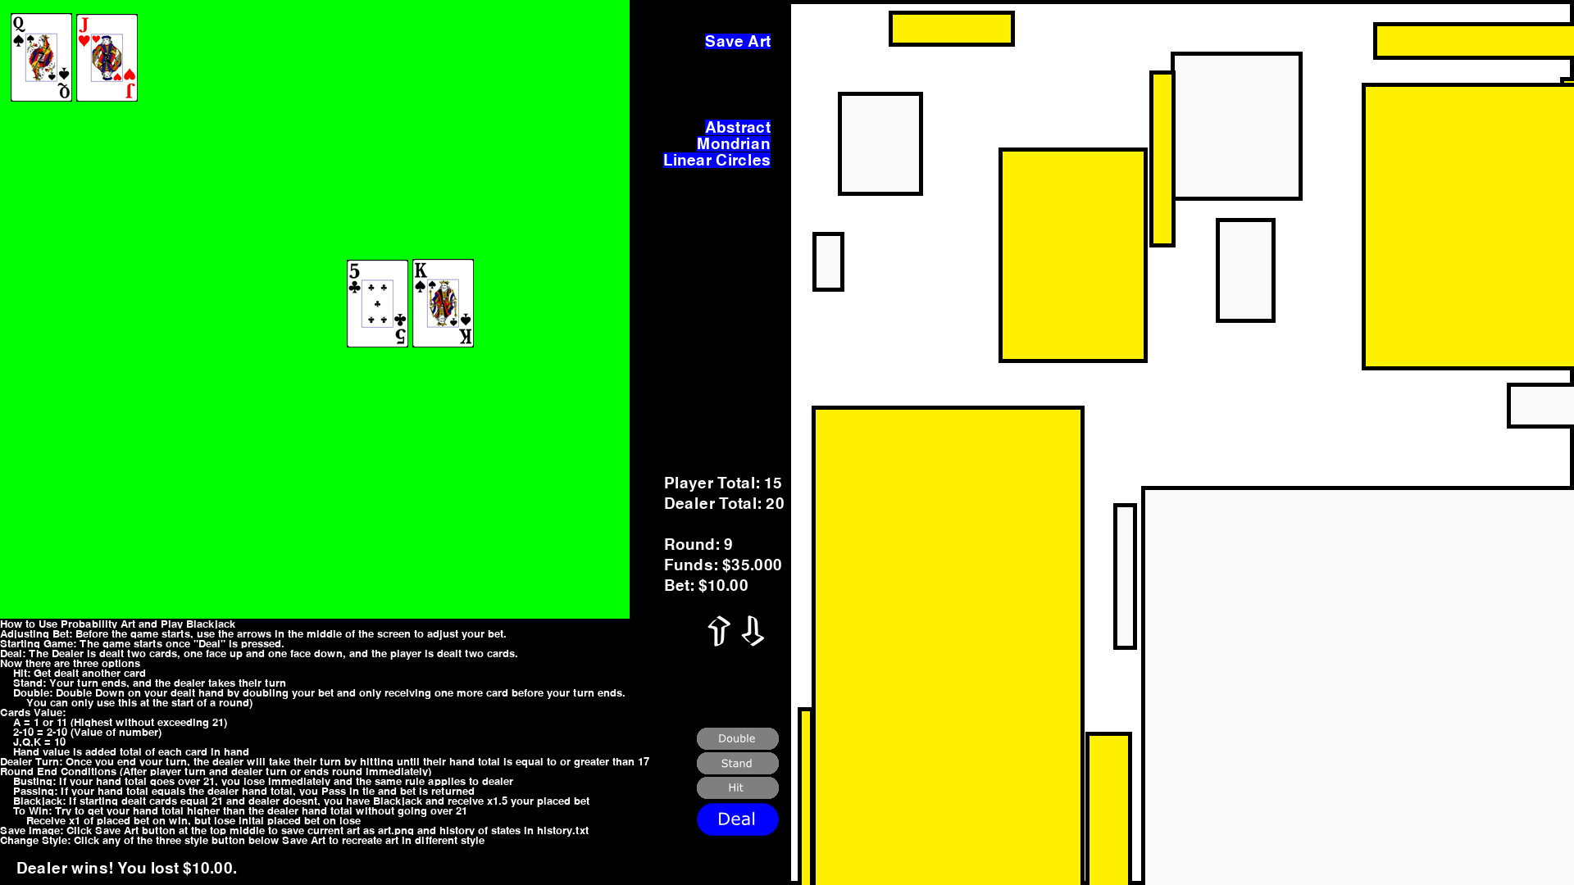

After you are satisfied with the generated art, you can save the art as well as the states of the game that went into creating that art. You will be able to see just how those different probabilities and states affected your art. Hop on now and enjoy a game of blackjack while visualizing your experience!

Original Code for blackjack from <https://www.pygame.org/project/640>